Conceptual Links. Knowing what is the same to identity what is different.

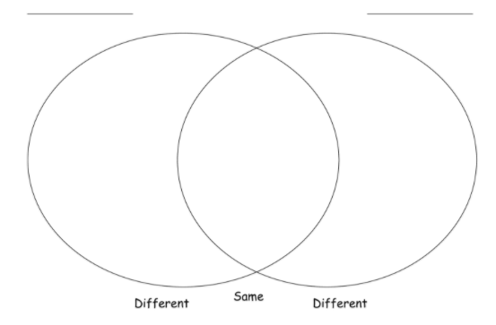
The hinge point is _______________________

Planning Document

 | Lesson 1-4 (Week 1) | Lesson 5-8 (Week 2) | Lesson 9-12 (Week 3)
Year # Differentiation

Whole Class
(Baseline)

Year # Differentiation

Math Workshop Template

Topic: Date:
Achievement Statement:
5-10 minutes | NUMBER SENSE ROUTINE - WHOLE GROUP  SHORT ACTIVITY TO REVIEW PRE-REQUISITES, PROMOTE DISCOURSE, INCREASE ENGAGEMENT  FOR IDEAS CHECK: STEPPING STONES STEP 2 (STARTING THE LESSON), FLARE, FUNDAMENTALS, BIG BOOKS
15 minutes | FOCUS LESSON - WHOLE GROUP  THE CONCEPTUAL PART OF THE LESSON THAT FOCUSES ON THE BIG IEAS(S) BEING EXPLORED  FOR IDEAS CHECK: STEPPING STONES STEP 3 (TEACHING THE LESSON OR MATHEDOLOGY VIDEOS)
30 minutes | GUIDED MATH - SMALL GROUP  FOCUS/GUIDED INSTRUCTION WHERE THE TEACHER SITS WITH A SMALL GROUP OF STUDENTS TO CHECK FOR UNDERSTANDING  FOR IDEAS CHECK: STEP IN DISCUSSION, DIFFERENTIATION | LEARNING STATIONS - SMALL GROUP  SMALL GROUP/PAIRED/INDIVIDUAL WORK WHERE THE STUDENTS WORK LARGELY WITHOUT TEACHER SUPPORT  FOR IDEAS CHECK: DIFFERENTIATION, MORE MATH, FUNDAMENTALS, BIG BOOKS
5-10 minutes | STUDENT REFLECTION - WHOLE GROUP  AN OPPORTUNITY TO REINFORCE THE BIG IDEA(S) & REFLECT ON STRATEGIES AND THINKING  FOR IDEAS CHECK: STEPPING STONES STEP 4 (REFLECTING ON THE WORK)

